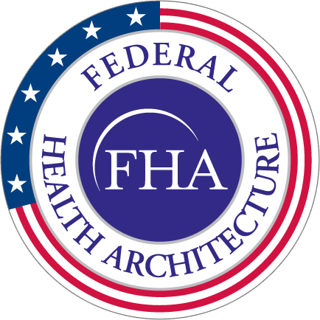**MEETING TITLE Agenda**

**DAY, DATE**

**TIME / Capitol View**

**HIM WG Minutes – 3/8/2016**

|  |  |  |
| --- | --- | --- |
| 1:00 – 1:10 | Welcome and roll call   * Attendees: Steve Wagner, Gary Dickinson, Galen Mulrooney, Jay Lyle, Mulikat Sarumi, Nona Hall, Bob Bishop, Steve Hufnagle, Subash Kafi, William Half, Susan Campbell, Alberto Llanes, David Bass, Bob Sadler, Pamela Price | Steve Wagner |
| 1:10 - 1:15 | Update on three FHIM information domains to be distributed to the federal partners for review/feedback   * The UML model is done first in conjunction with the subject matter experts followed by the terminology modeling. This work has been done for quite a while. Jay and Galen need to create the terminology classes where they do not exist and create the binding. Steve Hufnagle is assisting in cleaning up the definitions. Should be complete within the next couple of weeks. Many of the targeted vocabularies do not currently exist so the value sets need to be created. The publication format that we have been using is able to pull out the vocabularies. * Nona asked for clarification on the publication format and Steve said that the older publication formats could be sent out as examples and would be published on their new site. Current website will be posted in future meeting invites and domain spreadsheets will be sent out periodically for review. | Galen Mulrooney |
| 1:15- 1:55 | Presentation and discussion on Terminologies, Value Sets and the VSAC Repository   * See slides for presentation content. * UML license can be applied for to review and provide feedback on VSAC Repository. The license is needed to access the site. License application can be accessed here: <https://www.nlm.nih.gov/databases/umls.html>. * Galen asked whether there is the capability of downloading value sets from the VSAC Repository. Jay confirmed that it is downloadable in Excel format. * Concern expressed that agencies would forget to update value sets in the VSAC Repository after updating them within the organization. Rob was working on the capability for automatic updating/downloading of value set changes. Jay has been told that there is movement in that direction. * VSAC can currently handle extentional value sets but not yet intentional value sets. Question raised whether they intend to include intentional value sets. Jay answered that this is probably on the to-do list, but is not sure of its priority status. * Mulikat asked whether the VSAC contains the standards recommended by the Interoperability Standards Advisory (ISA). Steve confirms that it has all value sets that support meaningful use. All the C-CDA value sets are either complete or nearly complete in the VSAC. Nona shares that most of what the ISA recommends is reflected in the VSAC. Nona will take this back to the ISA as a suggestion. She will share a link to the ISA best available standards. | Jay Lyle and Rob McClure |
| 1:55 – 2:00 | Wrap-up, and action items   * Nona shared the announcement about the ONC Tech Lab, specifically the Interoperability Proving Ground. You will be able to put in the initiative that you’re working on, the POC, and the link to the work. It will also allow for us to get updates on initiatives that we are interested in following up on. Nona suggests that this initiative be entered when the Proving Ground is started. | Steve Wagner |